Farmers ZSOA
Zurich Services Oriented Architecture

FNOL – Postal Address Manager Service
Technical Design

Version 1.0



Farmers Service Competency Center

Copyright Zurich Financial Services

Document History

Version | Date | Author | Comment
1.0 | 06/10/2008 | Emmanuel Ameh | Initial Draft

Table of Contents
1 About this Document 5
1.1 Introduction 5
1.2 Intended Audience 5
1.3 How this document is organized 5
1.4 Reference Architecture 5
1.5 Service Overview 7
Orchestration Layer Components 9
1.6 ESB Components 9
1.6.1 ALSB 9
1.7 Client interface 10
1.8 Message flow 11
1.9 Transformations 11
1.10 Routing 11
1.11 Interface 11
1.11.1 Functionality Required 11
1.11.2 Inputs 11
1.11.3 Outputs 12
1.11.4 Faults 12
1.11.5 Data Modifications 12
2 Implementation Layer Components 14
2.1 Class Diagram 14
2.2 Mainframe Programs 15
2.2.1 Program Name 15
2.2.2 Region 15
2.2.3 Linkage section 15
2.2.4 Procedure Division declaration 15
2.3 EJB’s 15
2.4 Database\Stored Procedures 15
3 Functional\Non-functional requirements 16
3.1 Functional 16
3.1.1 Feature specifications 16
3.2 Non-functional 16
3.2.1 Security 16
3.2.2 Logging 16
Logging is provided by Amber-point 16
3.2.3 Monitoring 16
3.2.4 Business exception handling 16
3.2.5 Response time 16
3.2.6 Concurrent Users 16
3.2.7 Throughput Requirements 16
3.2.8 Availability 16
4 Business Contacts 17

About this Document

Introduction
This document describes the design artifacts and implementation model of the Postal Address Manager Service. Although external systems (upstream and downstream) are referenced in this document, their detailed behavior falls outside the scope of this document. Overall system requirements are covered in the requirements and use case document and, therefore, also fall outside the scope of this document.

Intended Audience
This document is intended for the team members who will be responsible for development of this service.

How this document is organized
The design for the Postal Address Service is presented in 4 areas of interest as outlined below.
- Orchestration Layer Components: Presents the services, components and information pertinent to this level. The primary focus here is on the Enterprise Service Bus and the activities carried out there.
- Service Enablement Layer Components: Describes the design and pertinent aspects needed to develop the atomic services as well as any other aspects implemented at this level.
- Implementation Layer Components: This deals primarily with backend or legacy data sources and the design to follow in exposing their services to the enterprise.
- Functional\Non-functional Requirements: This section outlines the functional and non-functional requirements identified for this service.

Reference Architecture
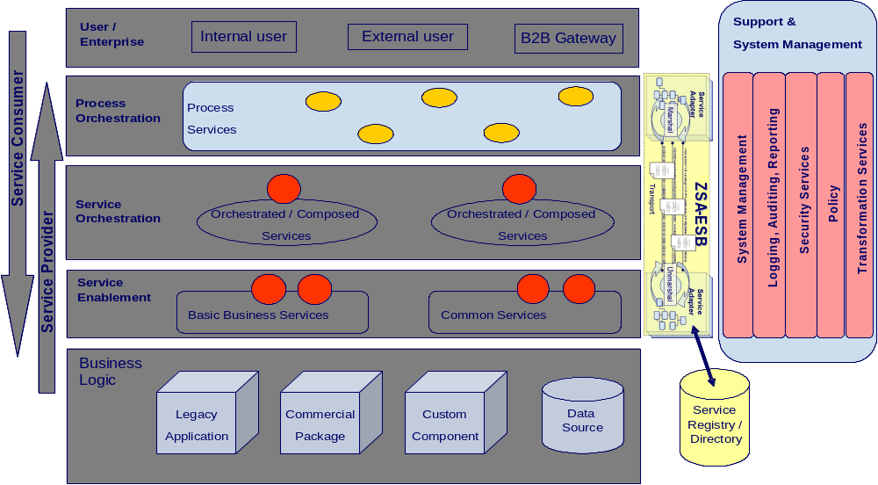

Fig 1.1
As shown in the above diagram, the Postal Address Manager Service will follow the reference architecture defined in the “ZSA_Tech_Ref_Architecture” document.
No special implementation is required for security and transformation for providing web services to the (Consumer). The details of the base implementation are explained below:
The end-to-end flow for the provider MAPPOINT will follow the steps shown in the diagram 1.2:

PEGA
(FNOL - AUTO)

O R
LOAD BALANCER
ALSB
getRoute( )
getLocationMap( )
Data Power
(Data Transformation)
MAPPOINT
( PROVIDER)

IAA Request

O R

Diagram 1.2

As shown in diagram 1.2, PEGA / FNOL - Auto consumer sends the zip code as string and gets a response which contains the Map and directions to the provider’s location.

Service Overview
This service will return the location map and the directions to the location depending on the address selected by the service consumer.
The following diagram gives a high level overview of the service’s structure. As per the reference architecture, Party Object has implementation components in the Service Enablement, Atomic, and Orchestrated layers.

PEGA
(FNOL - AUTO)

.

PARTY

IPostalAddressManager:
getRoute( )
getLocationMap( )

ZSOA / FARMERS
INTERNAL

SOAP / HTTP
MAPPOINT
(PROVIDER)

Anticipated URLs:
Development: http://testdev.farmersinsurance.com/FarmersLocationSearch/SearchResults.aspx
QA: http://qa.farmersinsurance.com/FarmersLocationSearch/SearchResults.aspx
Maintenance: http://maint.farmersinsurance.com/FarmersLocationSearch/SearchResults.aspx
Production: http://crn.farmersinsurance.com/FarmersLocationSearch/SearchResults.aspx

4. Two web pages will be developed by INET that will display Map Location and Driving Directions. These pages will be available to Siebel indirectly and the main Farmers Insurance Group site directly for integrating their Agent Search application.

Orchestration Layer Components

ESB Components

ALSB

1.6.1.1 Business Service
This section contains the detail necessary to define the business service in the ESB.

General Configuration
Service Name | PostalAddressManager - Business Service
Description | The purpose of PostalAddressManager service is to retrieve the provider’s location map as well as the directions to the location.
Service Type | Web Service
Transport Configuration
Protocol | HTTP
Load balancing | No
Endpoint URI | http://services.farmersinsurance.com/services/<<tbd>>
Retry count | 0
Retry interval | 0 seconds
HTTP Transport Configuration
Timeout | Default to server
HTTP Request Method | Post
Authentication | No
Follow HTTP redirects | No
SOAP Binding Configuration
Enforce WS-I Compliance | Yes

1.6.1.2 Proxy Service
This section contains the detail necessary to define the proxy service in the ESB.

General Configuration
Service Name | PostalAddressManagerProxyService
Description | This services fronts the primary business service
Service Type | WSDL Web Service
Proxy Service Provider | N/A
Protocol | HTTP
Endpoint URI | http://services.farmersinsurance.com/services/<<tbd>>_proxyService
Get All Headers | No
Headers | N/A
HTTP Transport Configuration
Authentication | No
Message Level Security Configuration
Custom Authentication | No
Operation Selection Configuration
Enforce WS-I Compliance | Yes
Selection Algorithm | SOAP Body Type

1.6.1.3 WSDL
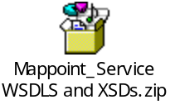

Client interface
A consumer will access this service via a WS-I v1.0-compliant web service invocation. This service uses the wrapped document literal binding style. The request/response messages are in IAA canonical format and the consumer has the responsibility to map the XML message structure to their internal format.

Message flow
Message Flows are the definitions of AquaLogic Service Bus proxy services. Pipelines (Request and Response pipelines), branch nodes, and route nodes define the implementation of AquaLogic Service Bus proxy services. There will be a Pipeline Pair required to handle the request and response, and Route node required and there is no requirement for branch nodes. ALSB which provides a route node is used to perform request/response communication with Proxy service and Mappoint service. The route node supports conditional routing as well as request and response transformations.

Transformations
Data transformation is the mapping of data from one format to another. DataPower transforms messages from IAA format to the service provider’s format. It uses the Xquery, XSLT transformation and XPath language for data composition and transformation for service endpoints. Data power supports data mapping that uses XQuery and the eXtensible Stylesheet Language Transformation (XSLT) standards. There is no data transformation since Mappoint (provider) identifies SOAP/HTTP messages.

Routing
There is no need for routing as there is only one provider for the consumer of this service. FNOL is sending request to Mappoint.
Service Enablement Layer Components

Interface
The Postal Address Manager Service is to be the result of building a service layer to interact with new third party vendor providers.

Functionality Required
A new service is to be enabled under Party Package in IAA. The WSDL files to be implemented for this service are located in section 1.6.1.3. Service enabling this new calling program will require mapping of the ZIAA canonical model to the existing inputs and outputs. The following table shows the native input\output elements to ZIAA WSDL mappings. The Mappoint WSDL operations from provider are getRoute( ) and getLocationMap( ).
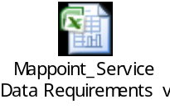

Inputs
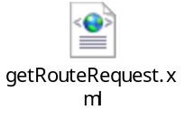

Outputs
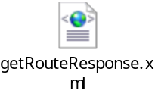

Faults

U.C. Parameter | Element | Type | Schema
Technical Error | errorMessageType | String | (ZSOA.xsd)
Business Error | errorState | String | (ZSOA.xsd)

Data Modifications
Identify any data modifications which need to occur in the service enablement layer.
Field Name | Modifications
None

1.11.6 Logical Flowchart

Begin
ZIP
Call Mappoint Service to display directions and location map
Mappoint processes the request
processes the request
End
Yes
Success/failure

Create Error Message
Failure
Send response through ALSB to FNOL - AUTO
Success

Implementation Layer Components

Class Diagram

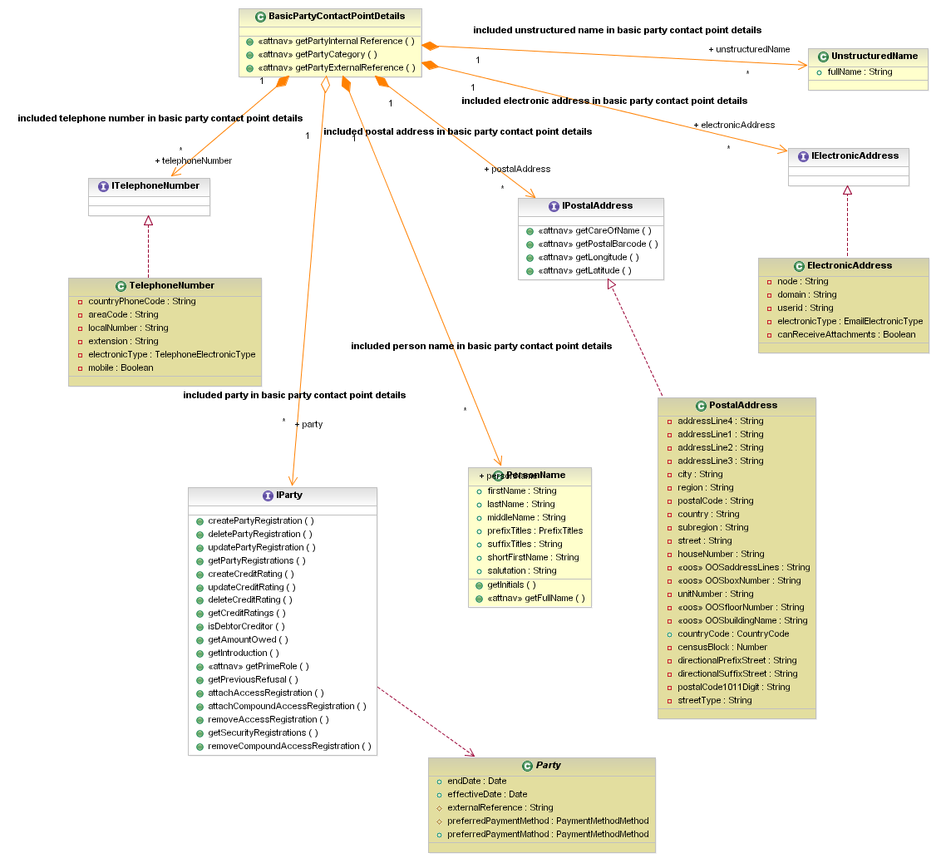

Mainframe Programs
<<None>>

Program Name
<<None>>

Region
<<None>>

Linkage section
<<None>>

Procedure Division declaration
<<None>>

EJB’s
<<None>>

Database\Stored Procedures
<<None>>

Functional\Non-functional requirements

Functional

Feature specifications
No special features are specified for the functional requirements

Non-functional

Security
Since both the providers are public network, there is no message level and transport level security needed for this service. However, the service should be accessible within Farmers’ domain.

Logging

Logging is provided by Amber-point

Monitoring
Monitoring is performed by Amber-point

Business exception handling
Return data error message when zip code entered for request is wrong.

Response time
The response time should be within 3sec.

Concurrent Users
PEGA, FNOL - Auto

Throughput Requirements
The throughput expectations from FNOL- Auto Mappoint system is around 30,000 (service requests) / day.

Availability
As far as availability is concerned, the Postal Address Manager system is available 100% of the time.

Business Contacts
Name | Company | Role | Email address
Kathy Hartley | Famers,HO | Program Manger | kathy_hartley@farmersinsurance.com
Goutham Nellutla | Farmers | Program Manager, Farmers Services Competency Center | goutham.nellutla@farmersinsurance.com
Mukesh Agrawal | Farmers | Program Manger | Mukesh.agrawal@farmersinsurance.com
Venkatakrishna Pushpala | FNOL - WC | Integration Team Lead | Venkatakrishna.pushpala@farmersinsurance.com

